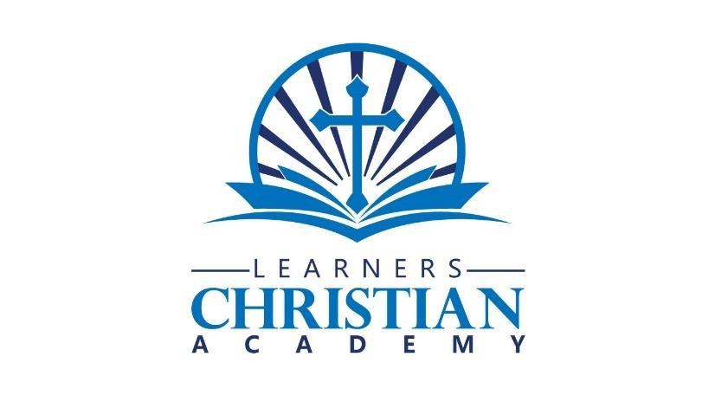
MEDIA RELEASE FORM
Academic

Learners Christian Academy uses photos and video in its publications and promotional materials. This form simply gives permission for images of the participant named to be used as outlined below.

Organization: Learners Christian Academy

Participant’s Name: ______________________________________________________
(Person being photographed or videotaped)

Participant’s Address: ______________________________________________________________________

Participant’s Telephone Number: ___________________________________________

I hereby consent and authorize Learners Christian Academy to use my name and/or the names of my family members who are minors, as listed above, as well as my likeness, photos, videos and other information (or that of family members who are minors) for the purpose of news releases, advertising, publicity, publication or distribution in all forms and media. I further consent to such use in their present form and to any changes, alterations, or additions thereto. I hereby release Learners Christian Academy from all liability in connection with all such uses.

__________________________________________ _________________________
Participant/Guardian’s Signature Date
(A parent or guardian must sign above if the participant if under age 18.)

Mark this box if you DO NOT consent or authorize.

__________________________________________ _________________________
Participant/Guardian’s Signature Date
(A parent or guardian must sign above if the participant if under age 18.)

Witness: (anyone who watches as this form is filled out)

___________________________________________________ ________________________________ Print Name
Date

Learners Christian Academy
800 N. Pine Hills Rd. • Orlando, FL 32808• Phone: 407-952-5213
Website: www.learnerschristianacademy.com

April 18, 2025

