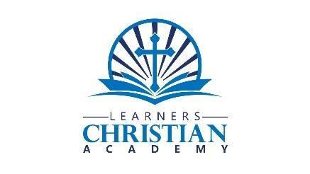

iPad, Tablet, and Computer User Policy

I understand the use of an iPad, tablet, or computer at Christian Learners Academy (LCA) is to be exclusively used for instructional purposes. It is NOT to be used as entertainment.

- I may NOT download any application or any media content on an LCA iPad, tablet, or computer without the express consent of my teacher.
- I will maintain the operating system and not change it.
- I will NOT deface the serial number.
- I will NOT take an LCA iPad, tablet, or computer beyond my classroom unless instructed by my teacher.
- I will leave my LCA iPad, tablet, or computer closed flat upon my desk.
- I will Never leave my LCA iPad, tablet, or computer unattended or share a different LCA iPad, tablet or computer unless by a teacher in case of emergency.
- I will be responsible for my LCA iPad, tablet, or computer assigned to me, and any damage that may occur while I am using it will be my responsibility to pay my portion of the cost of repairing the device.
- I will NOT take photos or record class lectures, discussions, etc. unless given permission from the instructor.
- I will protect my LCA iPad, tablet, or computer by ensuring that it remains in its proper case, closed appropriately, and will not stack anything upon it.
- I will not visit any social media sites, ie.: Facebook, twitter, shopping sites, etc. while using my LCA, iPad, tablet, or computer. Under NO circumstances will I share any personal information on any site, including name, address, phone number, family information, photos, or school location.
- I recognize that the administration and staff at LCA has the right to amend this User Policy at their discretion. I understand at that time I will be given another User Policy.

_____________________________________________
Student Signature Date

_____________________________________________
Parent/Guardian Signature Date

